**Assignment -1** Python Programming

|  |  |
| --- | --- |
| Assignment Date | 21 OCTOBER 2022 |
| Student Name | SHANJAY.V |
| Student Roll Number | 714019106101 |
| Maximum Marks | 2 Marks |

# Question-1:

Write a program which will find all such numbers which are divisible by 7 but are not a multiple of 5,between 2000 and 3200 (both included). The numbers obtained should be printed in a comma- separated sequence on a single line.

|  |
| --- |
| **Solution:** |
| l=[] |
| for i in range(2000, 3201): |
| if (i%7==0) and (i%5!=0): |
| l.append(str(i)) |
| print (','.join(l)) |

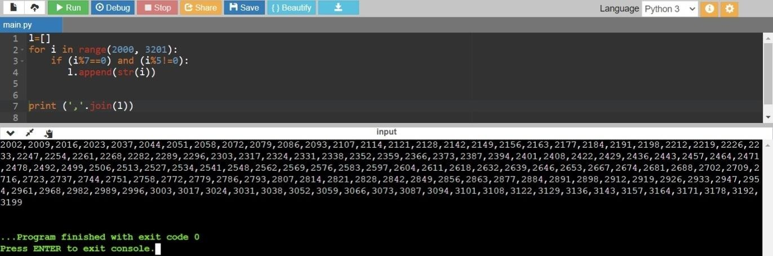

# Question-2:

With a given integral number n, write a program to generate a dictionary that contains (i, i*i) such that is an integral number between 1 and n (both included). and then the program should print the dictionary.

Suppose the following input is supplied to the program:8

Then, the output should be:

{1: 1, 2: 4, 3: 9, 4: 16, 5: 25, 6: 36, 7: 49, 8: 64}

|  |
| --- |
| **Solution:** |
| n=int(input()) |
| d=dict() |
| for i in range(1,n+1): |
| d[i]=i*i |
| print d |
| # # |
| # # |

